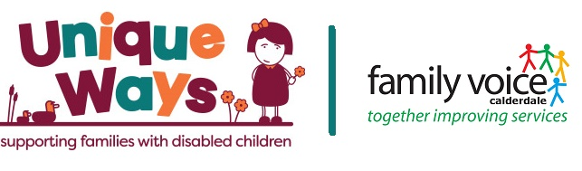

🌟 Join Family Voice Calderdale’s Steering Group 🌟
Voluntary Roles | Flexible Hours | Supporting SEND Families Across Calderdale
Family Voice Calderdale (FVC) is the Parent Carer Forum for Calderdale.
We are a group of parents and carers of children and young people with Special Educational Needs and/or Disabilities (SEND) who work together to make sure local services meet the real needs of families.
We belong to the National Network of Parent Carer Forums (NNPCF), ensuring Calderdale families’ voices are represented locally, regionally, and nationally.
What We Do
Family Voice Calderdale ensures that Parent Carers have a voice in shaping services for children and young people with additional needs.
We:
- Seek and represent the collective voice of Parent Carers.
- Active co-production.
- Work with Calderdale Council, the NHS, schools, and community organisations to make sure services meet family needs.
We are not a support group, advocacy service, or campaigning organisation and we do not undertake individual casework. Our focus is on strategic influence and co-production — making a difference through partnership working.
About the Steering Group
Our Steering Group is made up of volunteer Parent Carers who meet monthly to guide and oversee Family Voice Calderdale’s work.
As a Steering Group Member, you’ll:
- Represent the lived experiences and perspectives of Calderdale families.
- Help shape SEND services and policies through meetings, panels, and workstreams.
- Contribute to planning and decision-making about Family Voice Calderdale’s direction and priorities.
- Work in partnership with key local decision-makers, ensuring parent voice is always heard.
This is a voluntary role, designed to fit around family life.
Expenses (travel, childcare, etc.) are reimbursed, and all members have access to training, induction, and ongoing support.
Who We’re Looking For
We’d especially like to hear from people with experience or insight in:
- Parent Carers with lived experience navigating SEND systems.
- Mental health and emotional wellbeing.
- Specialist or inclusive education (teachers, SENCOs, or school-based professionals).
- Diversity and inclusion; representing under-represented communities.
- Medical or complex health needs.
- Male Parent Carers.
You don’t need previous governance or committee experience — we’ll provide any training you need.
Why Get Involved
- Make a genuine difference to SEND services in Calderdale
- Share your experiences to help shape positive change
- Develop new skills and confidence
- Be part of a welcoming, supportive, and passionate parent-led team
How to Apply
Role Profile packs are available on our website.
If you’d like an informal chat about this voluntary role, please contact chair@familyvoicecalderdale.org.uk .

We welcome and encourage applications from all backgrounds, communities, and experiences.
Your voice matters — and together, we can make it heard.
_______________________________________________________________________

