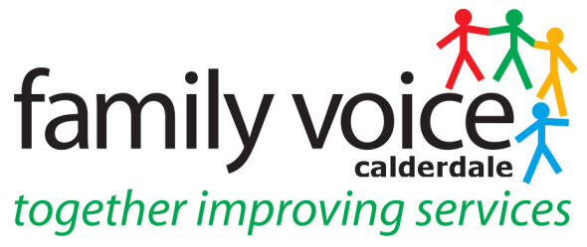

STEERING GROUP MEETING WED 14th July 2021
MINUTES
via Zoom

- Welcome and apologies
Steering Group Members: Alison Sharpe, Cath Howard, Pete Ruse, Heidi Coney (UW)

Apologies: None

- Items for AOB
Community Care Charge Focus Group
Transforming Care & Inpatient Admissions
_________________________________________________________________

- Minutes of Last Meeting on 23rd June and Matters Arising
All SG members agreed minutes of 23rd June were a true and accurate record however item 9 needs amending to say that Alison agreed to help with writing of the mental health survey report at the meeting.

Conduct at Meetings Document – amends have been done by Heidi re multi-tasking and keeping video on where possible. Language & tone of document not changed ACTION: Heidi will liaise with Cath to do this.

- Discretionary Grant (now Priority Grant)
The name of the discretionary grant has now been changed to the Priority Grant and cannot apply for this grant until the forum has had the grant application approved by Contact. When this is approved will look at ideas for spending the priority grant and an additional £1,000 was suggested in order to cover the costs of ongoing training and recruitment. ACTION: Heidi will ask Lisa Aldred where grant application up to and put forward initial ideas for priority grant
__________________________________________________________________

- Steering Group/Parent Rep Recruitment & Training Strategy
Pete updated on meeting with Liz Wilson on 29/6 – training will involve a 6 week course much like the structure of the Insiders Guide and will have activities and guest speakers from SEN Team, CAMHS & Social Services. It will be skills based and cover such topics as ethical boundaries, interacting with Commissioners and Confidence building. Recruitment for the course will start after the summer term for the 6 weeks up to the start of the course. UW staff will not join the training or be involved due to capacity issues. Liz will plan and deliver the sessions but the SG will attend as a resource and also as attendees receiving the training.

_______________________________________________________________

- Conference 2021 Interviews
The next interview is taking place on Wed 21st July. Pete has met with Dr Katie Gregson Curtis and has an interview plan that he will send round for comments. Future interviewees are Glenn Swindell and Libby Smith and Pete suggested that one interview a term as a great platform for FVC. ACTION: Pete will contact Glenn and Libby about interviewing them in the Autumn Term. Cath asked if interviews could be released as podcasts too. ACTION: Heidi will speak to Martin about the next one being released as the option to just listen to the soundtrack

__________________________________________________________________

- Parent Rep/Workstream/Panel Feedback

Neurodevelopmental Steering Group – Pete is in a subgroup to this that is looking at information on the website that will be hosted by Open Minds Partnership. There is now a Patient Choice in Autism subgroup of which there is a NAS representative and a lawyer. Issues brought up at this group could increase waiting lists in Calderdale.
Preparing for Adulthood – Alison attended a regional meeting and there was a presentation by Alice McCol who is the regional lead on PFA. More sessions will follow in the autumn, asked about what they want for the region and to find out what working well. Time to Talk – is a 3 year funding project for mental health and PFA where you can access 4-6 free online counselling sessions.
Workstreams – Pete reported he has an update meeting with Ben Allchin and Lesley Bowyer which will include information on governance & structure of workstreams.
Short Breaks Panel – Cath reported there will be a panel review. They also have new short breaks providers and an increase in applications. ACTION: Cath will send dates of future SB Panels to Heidi
Happy Holidays Club – Pete reported Jess Heald is the new Happy Holidays Co-ordinator for those on Free School meals and especially those with additional needs. This funding stream will continue beyond the summer break.
Open Minds Partnership – Heidi reported she had attended this meeting and presented on how FVC involved in mental health survey and feedback was positive.
Night Owls Crisis Line – this is now up and running and Alison has agreed to attend further meetings and also with regard to work sent through on Transforming Care.
__________________________________________________________________

- Date of future Steering Group Meetings

SG pencilled in date for next meeting - Wednesday 15th September

__________________________________________________________________

- AOB
Community Care Charge – the flyer for the focus group has gone out and the deadline is the 19th July, currently there are only a couple of parents who are interested. Cath, Pete and Heidi will meet to discuss following week. Cath suggested it would be better to use Microsoft Teams format for focus group but currently can’t do this with individuals outside UW’s. ACTION: Heidi will speak to Martin re upgrading the Microsoft Teams license to include members outside UW and look at cost of this.

__________________________________________________________________

Date of Next Meeting – Wednesday 15th September 2021 at 10.30 via Zoom

