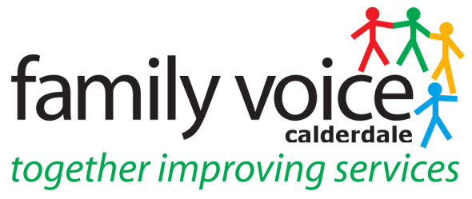

STEERING GROUP MEETING MINUTES
Wednesday 12th October 2022
11.30 – 2.00pm
Family Room, Unique Ways Office, Hanson Lane

- Welcome and apologies
Steering Group Members: Danielle Durrans, Emma Chadwick, Rebecca Stead, Alison Sharpe, Catherine Howard, Sarah Campbell, Kay Scott Unique Ways: Heidi Coney Guests: Stevie Stott, Charmaine Stowe Apologies: Beverley Leslie, Levi Maude, Leah Webster, Liz Slomski
__________________________________________________________________

- Items for AOB
None

__________________________________________________________________

- Declarations of Interest

None
____________________________________________________________

- Minutes of Previous Meeting on 28th September
SG agreed as a true and accurate record
__________________________________________________________________

- Chairs Update

No Chairs update due to illness
__________________________________________________________________

- Terms of Reference

All SG agreed on amends. Heidi will send and bring papers copies to the November meeting for signing.

- Transport/Carers Rights Day
Transport/Carers Rights Day event suggested for the 24th November on Carers Rights Day. SG discussed transport issues, these seem to be more about quality of the service and some children having to spend up to 5 hours a day on buses. SG want to work with Transport dept to look at these issues. Discussed FVC transport paper submitted to council by FVC and Martin gave an update on this. This had contributed to petition started by Holly Lynch to make post 16 transport funding for SEND statutory for all local authorities and Heidi will resend petition. Heidi contacted Gavin at SENTASS to attend event and let council/transport dept know we are planning this. Danielle suggested writing to Tracy Brabin, West Yorkshire Mayor on public transport issues. FVC keen to work with the council to improve the service and a task and finish group is maybe what is required.

_______________________________________________________________

- Parent Rep Feedback on working groups/panels

Silver Cloud Online Programme Focus Group – taking place on the 2nd November, Danielle, Rebecca, Emma and Stevie are interested and Heidi will send the link.
Early Years Autism Pathway Focus Group – led by a consultant this will involve helping develop guidance for parents. Heidi asked SG if knew anyone who had recent experience of the pathway.
WYHCP Autism Access Pathway – Alison currently attending these meetings but feels now not appropriate person to attend. Rebecca can attend the next meeting on the 20th October.
EHC Mod Panel – Alison gave feedback on the panel and will continue to attend. Will ask at next meeting if able to have another SG member to shadow her on this panel and will look at this happening from Jan 2023.
Short Breaks Panel – Cath and Leah are sharing this role on the panel. Need to decide who doing which panels for 2023.

Date of the Next Meeting – Wednesday 16th November at 11.30am at the Elsie Whiteley Centre

