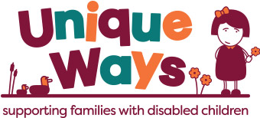

**Volunteering Opportunity With Unique Ways**

**Volunteer Role:**

Membership Support Administrator

**Timescales:**

Applications open Monday 2nd October 2023

Closing date Tuesday 31st October 2023

Provisional date for interview Thursday 9th November 2023

Provisional start date Monday 20th November 2023

The ideal candidate will have a good understanding of the issues faced by Parent Carers of children with disabilities and additional needs. Confidence, combined with excellent administration, organisation and planning skills will go a long way in this role.

Full training will be given.

Although we are flexible in agreeing the specific hours and volunteering pattern, we are looking for a real commitment to the agreed hours on a weekly basis, ideally 5 – 10 hours per week across 1 -2 days. Ad-hoc hours will not meet the business needs of the charity therefore unfortunately we cannot offer this role on an ad-hoc basis.

If you think you could make a positive impact to the lives of families with disabled children in Calderdale, application packs can be requested by telephone on **01422 343 090** or please email [volunteers@uniqueways.org.uk](mailto:volunteers@uniqueways.org.uk)

For an informal chat about the role, please contact:-

**Nicola Hanson, Membership Co-ordinator – Monday – Thursday 0930 – 2.30**

**01422 343 090.**

**\*\*\***