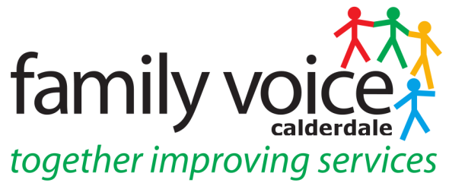

STEERING GROUP MEETING WED 31st MARCH 2021
MINUTES
via Zoom

- Welcome and apologies
Steering Group Members: Gabriella Walker, Alison Sharpe, Cath Howard, Pete Ruse, Heidi Coney (UW), Martin Reynolds (UW) Danielle Durrans (Guest)

Apologies: None

- Items for AOB
UW Annual Survey
__________________________________________________________________

- Minutes of Last Meeting on 10th March and Matters Arising
All SG members agreed minutes of 10th March were true and accurate record.

Unique Ways Education practitioner post has been advertised and interviews are taking place later on in April. Membership Officer is due to start on the 19th April and Benefits Advisor due to start on 26th April, both working 20 hours over 4 days.

- Treasurers Report

See update below under Item 5
__________________________________________________________________

- Grant Spend 2020/21
Dept of Ed grant has to be spent by 31st March. Heidi is liaising with Ben at Contact and Lisa Regional Advisor to ensure the proposals for what FVC planning to spend the money on is satisfactory. This is – printing of Charter – 2K copies, Laptops x2, tablets x10, tablet stands x2, Charter Banners x2, software including subscriptions to Doodle and Menti. It was suggested another laptop should be purchased so that the FVC Co-ordinator and both chairs have one. All SG agreed this spend and there may be some of the grant leftover

_______________________________________________________________

6. FVC Conference 2021 Q&A

Pete updated that he had contacted Lesley Bowyer re possible dates when the Q&A could be recorded and she hadn’t as yet got back to him. Technical issues were talked about and how it would be done on Zoom and then edited by Martin before being put on you tube so parents could watch at leisure.

_______________________________________________________________

7. Green Prescribing

There has been some funding made available in Calderdale for green prescribing projects and although FVC can support others in applying for these bids FVC doesn’t have capacity to apply for them. Gabriella updated there was a £250K pot of funds but due to no one having the time, the money had not come to Calderdale.

8. Neurodiversity Project

Gabriella updated on the focus group of 25th March, a lot of very useful and positive feedback came out of it and that parents were keen to stay involved. The rest of the budget that is £20K will be spent on creating the 3 modules involved in the Health Visitor training and this will be delivered online.

__________________________________________________________________

9. Workstream/Panel Feedback

- Neurodevelopmental Steering Group – this group is looking at all communication from Open Minds partnership and Pete is involved in this. Patient Choice in Assessment also came up and Janine came along as the NAS Rep.
- Personal Budgets Panel – this newly formed panel which Pete is sitting on along with representatives of CAMHS. They have 4 cases already and meets every month although it is smaller than Short Breaks Panel.
- Short Break and EHC Moderation Panel are ongoing. Discussion then came up on what Short Breaks money can be used for as this is causing confusion for some parents and need clarity and wanting to know how flexible is flexible. Cath said she would ask for it to be put on the next Short Breaks Panel as an agenda item so she could bring this up and Gabriella suggested some information was needed so clear for all those involved.
- Short Breaks Group – Cath had met with Glenn Swindell to look at ways of finding a good PA.
- Pete had been approached by COE of Kingston Upon Thames Council to take part in a peer review as they had failed an inspection.
- Community Care Charge – the report has gone out to all members and to council officials and there has been no feedback from the council. Cath asked if Katie Clarke could mention the report at a seminar she was conducting and Pete agreed. To continue work on this will look at holding a focus group in the coming weeks and Heidi will organise planning meeting with Cath & Pete.
- Alison attended Outcomes for PFA event for Y&H Region – this was an interesting event looking at planning for young people with SEND. Alison also attended SEND Review meeting as part of the virtual NNPCF National Conference and also a very useful training and information session on Kooth, the mental health app.
__________________________________________________________________

10. AOB - Annual Survey

Martin updated the UW survey will be going out on the 1st April for 1 month. There have been some changes made since initial draft when comments came back and it now flows more easily. There will be a prize draw for completing and it will close at the end of April. If all SG could share the link and encourage parent carers to complete. Although UW/FVC is working hard to be inclusive this pandemic year has meant not been able to get in touch with those community groups where English is not the first language and may need help with completing the form. Gabriella suggested idea of multilingual survey however this costs - £1,188. FVC/UW will try to build in to planning for next year to reach those groups who may be under represented in completing the survey.

__________________________________________________________________

Date of Next Meeting – Wednesday 26th May 2021 at 10.30 via Zoom

