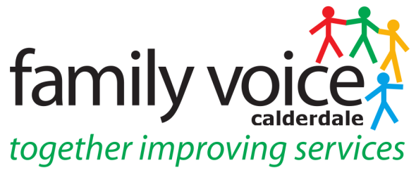

STEERING GROUP MEETING 9th DECEMBER 2020
MINUTES
via Zoom

- Welcome and apologies
Steering Group Members: Pete Ruse, (chaired this meeting), Alison Sharpe, Gabriella Walker, Heidi Coney (UW), Martin Reynolds (UW)

Apologies: Janine Wigmore, Cath Howard and Alison Bower

2. Any Other Business

Any Other Business items for the agenda are Annual Health Checks, Neurodiversity Project and UW Survey
__________________________________________________________________

3. Minutes of previous meeting and Matters Arising

11th November: confirmed as accurate record apart from amending to correct spelling of surname – Ben Allchin.

4. Treasurer’s Report

Nothing to report as there has been very little spend. Reminded SG to send timesheets in to Martin electronically and go back to the 1st April 2020 to include any council meetings they may have attended during lockdown.
__________________________________________________________________

5. FVC Conference 2021

Martin outlined results of the UW Survey in relation to FVC and very useful for Conference planning. Results showed 50% of UW members had not heard of FVC, 81% of UW members not attended the conference and work came up most frequently as the reason and 89% would like to hear more about FVC. Heidi will circulate complete survey results to SG.

SG discussed other groups to send the Conference invite to - SENCO’s, Public Health, Children’s Disability Panel, Family Support Workers, Portage, CAMHS. Lesley Bowyer is speaking however need a representative of CAMHS and Social Care to speak. In terms of technology SG felt word clouds were a good idea to engage parents in a positive way. It was decided the theme would be - Better Conversations: Better Outcomes – Supporting Children and Young People in a Changing World. This will go on the invite along with details of the key speakers with other speakers to be announced and the invite will go out by the 16th Dec. SG discussed idea of a wellbeing session, when parents have booked on and attended, they could get a link to a session of mindfulness or yoga.

6. Surveys Update

Community Care Charge – this survey is now closed and the results are being looked at. A focus group was organised by Katie Clark however FVC may do another focus group.
Specialist Inclusion Service – survey has been sent to UW members and will close on December 11th. There is a basic survey sent out to SENCO’s and Andrew Beckett is co-ordinating this.
Neurodevelopmental Conditions Survey – Pete is co-producing survey with Dr Katie Gregson Curtis who is leading this piece of work about what feedback services ask for from parent carers of children with neurodevelopmental conditions.

7. Events

National Conference – this was held for a week from 30th Nov and SG members attended the different virtual events which gave ideas for the upcoming FVC Conference. Heidi attended Diverse Community Engagement webinar which was useful and could use slides when they are available and have as an agenda item on SG. Alison attended Engaging Children and Young People in Effective Decision Making and as a result felt that other forums engaged with Young people more and asked about their involvement in EHCP process in Calderdale which might be a good idea. Alison also attended Removing Barriers to Co-production webinar. All recordings of webinars will be available and Heidi will circulate to SG.

SWFT Focus Group – Alison attended a focus group organised by South West Yorkshire Partnership giving feedback on a Mental Health and Wellbeing Leaflet and reported it had been decided to produce a credit card style leaflet containing basic but important information.
__________________________________________________________________

8. Workstream/Panel Feedback

Disabled Children & Young People Board – Pete attended this meeting which is looking at rewriting the SEF which both UW and FVC will be involved in.
MOD Panel – Alison attended this and reported there are a lot of younger children coming through on the MOD panel which is a good sign.
High Needs Review – Gabriella reported that this panel will reconvene in the new year to decide what is to be done with the underspend.

__________________________________________________________________

9. AOB

Annual Health Checks – Gabriella reported she’s working on increasing uptake of Annual Health checks in the 14+ age range and that needs of teenagers will be different from those of adults. She would like to do a focus group or short survey to find out from families what they would expect from an Annual Health Check and what would encourage them to go for one. The process will start with a short survey to find out more from families.

Neurodiversity Project – Gabriella working on this project to increase understanding in Health Visitors of Neurodiversity and hopes to start rolling the training out in Jan/Feb 2021 and would like parents to deliver some aspects of the training. Will arrange to speak to Shona about recruiting UW parent members to do this training.

Date of Next Meeting – Wednesday 13th January 2021 at 10.30 via Zoom

