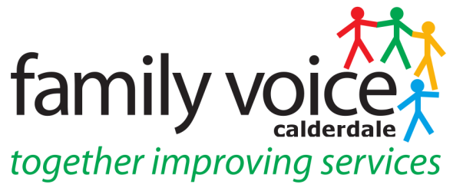

STEERING GROUP MEETING 13th October 2020
MINUTES
via Zoom

The SG meeting followed the Parent Representative training that was conducted by Lisa Aldred, the Contact Regional Parent Participation Advisor for Yorkshire and Humberside. The training covered how Contact supports parent carer forums, how it links to Dept of Education & NNPCF and roles within the forums.

- Welcome and apologies

Steering Group Members: Pete Ruse, (chaired this meeting), Alison Sharpe, Gabriella Walker, Janine Wigmore, Katie O’Connell-Binns (Guest) Michelle Rock-Davis (Guest), Heidi Coney (UW), Shona Walsh (UW), Lisa Aldred (Contact)

Apologies: Cath Howard and Alison Bower

2. Any Other Business

Any Other Business items for the agenda were discussed and incorporated into the agenda. These were the Treasurers Report, Funding Update and Equitable Charging Consultation.
__________________________________________________________________

3. Minutes of previous meeting and Matter Arising

9th September: confirmed as accurate record, proposed by Alison S and seconded by Pete.

4. Discussion & Election of Officer Roles

The SG discussed the chairing of the meetings and considered if it should be a single chair or co -chair. It was decided the current model of co-chairs was working and this should continue and was agreed by all 6 members of SG.

The Chair then asked for members to register interest in being Co-chairs and as there was only interest from Pete and Gabriella they were elected as Co-chairs.

Alison S nominated herself for the Treasurer role and as she was the only one nominated she was elected to this role.
__________________________________________________________________

5. Discussion & Nomination of Parent Representatives

A discussion then followed on the various workstream, groups and panels that include parent representatives from FVC.

Alison S would like to continue with Preparing for Adulthood workstream and there is a meeting on the 9th November via Zoom. Alison will attend this but will look at another parent rep attending too for future meetings.

Neurodiversity Group – which is the replacement for the ASD Steering group, Pete will attend this and Michelle expressed an interest in attending this group too.

Engagement & Participation Workstream – Heidi is attending the next meeting on the 23rd October and Katie expressed an interest in going along as a parent representative to this meeting. Heidi will send zoom link to Katie.

Local Offer Workstream – Cath Howard is happy to continue attending these meeting however it would be good for another parent representative to attend too.

EHWB Group – Pete will attend the next meeting on the 20th October as it is being replaced and changing its name and format. Michelle expressed an interest in attending this group and will be a better fit than neurodiversity group.

High Needs Review Workstream – Gabriella would like to continue attending this workstream and Katie was interested in attending and buddying up however was concerned re complexity of needs this workstream covered and would like more information from Gabriella.

__________________________________________________________________

6. Workstream/Panel Feedback

This agenda item was covered by item 5.

Pete and Alison S will alternate in attending the EHC Moderation Panel

7. FVC Conference 2021

The date set for the FVC Conference is the 4th February 2021 and it will be virtual. There will be a considerable amount of support needed from Martin to do this and will need to start planning as soon as possible and arrange a working group.

__________________________________________________________________

8. AOB

Treasurers Report – no updated report this month. Heidi will send out information and forms on how to claim expenses for all parent representatives

Unique Ways Funding – Shona updated that UW had applied for National Lottery Community Fund and been successful in securing £88K of emergency funding to cover October until March and this will extend the Ordinary Lives project. UW has also received 10K of funding from the Local Authority that can be used to fund core services. Shona is waiting for National Lottery to open its normal programme of funding in November to apply for. In addition hoping to use some restricted project money in other ways so in discussions with council and CCG about this.

Equitable Charging Consultation - there is currently a local authority consultation regarding charges that will affect over 18’s in receipt of certain community services. There is concern about this especially the timing – it went out during the summer when many stakeholders were furloughed. UW members have now been sent the consultation to give feedback and a letter has been sent to the cabinet member along with other council officials expressing FVC is not happy with consultation and hoping it will be extended.
__________________________________________________________________

9. Dates of Future Meetings

It was decided Wednesday’s at 10.30 were a suitable time to have the SG meetings and these will be on the 2nd Wednesday of the month. Heidi will send out an updated list of future meetings.

