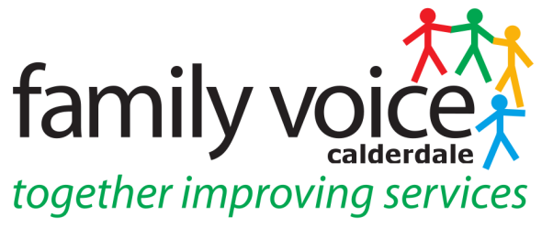

STEERING GROUP MEETING 11th NOVEMBER 2020
MINUTES
via Zoom

- Welcome and apologies

Steering Group Members: Pete Ruse, (chaired this meeting), Alison Sharpe, Katie O’Connell-Binns, Cath Howard, Heidi Coney (UW), Shona Walsh

Apologies: Janine Wigmore and Gabriella Walker

2. Any Other Business

Any Other Business items for the agenda were discussed and incorporated into the agenda.
__________________________________________________________________

3. Minutes of previous meeting and Matter Arising

13th October: confirmed as accurate record apart from changing Katie O’Connell-Binns from guest at meetings as she is a member of the SG.

4. Treasurer’s Report

Nothing to report as there has been no spend and all the expenses are in.
__________________________________________________________________

5. FVC Conference 2021

SG need to find some time to organise the conference for 2021 and weekly working group meetings will be set up w/c 16th November. Martin will come along to the meetings and the SG will need a lot of support as the Conference will be done virtually and want to avoid bombarding Martin with work at the end of the year/beginning of 2021. SG will think about technology and what they need and also themes and speakers they want to include.
__________________________________________________________________

6. Community Care Charge Consultation

Pete explained the Community Care Charge and issues with the Consultation to Katie and that a survey has gone out to residents in Calderdale about their experience of the Charge. The main issue is that it has not been co-produced. A focus group is also taking place on 13th November organised by Katie Clarke at ADCAF. Research from both the surveys and focus groups will be brought together to decide what the next steps will be. FVC is not fighting over whether the Charges come into effect but how these changes have been communicated. Reminders to complete the survey will be sent out before the closing date of the 16th November.

7. Upcoming Events

Carers Rights Day 26th November – organised in conjunction with Forget Me Not Hospice and PCAN, the Kirklees Parent Carer Forum. Will consist of 2 webinars, one on EHCP’s that will be facilitated by KIAS/SENDIASS and one on Care Assessments that will be presented by Janine. Forget Me Not will arranged the flyer to send out to our members who will then book on via Eventbrite.

Covid Economic Inequalities Focus Group 17th November – Cath queried whether this was from the point of view of individuals or the forum? Heidi will send request for attendees out to membership to ask if anyone been affected and would like to join in the conversation

__________________________________________________________________

8. Workstream/Panel Feedback

Preparing for Adulthood – Alison updated on this workstream. Project Search is continuing and they have 4 interns from last year and 6 interns this year. Yew Tree Housing project – the first tenants are moving in this week however there could be delays to all tenants moving in due to Covid. 2 new ventures happening – a horticulture venture at Cragg Vale and a Coffee Van. Ben Allchin, the SEN Officer looking at reviewing EHCP process as a considerable number do not attend reviews so want to look at reasons for this. Alison asked Pete if he wanted to be involved in this process and he suggested bringing it up at the next Moderation Panel. Alison expressed how it was good to regroup and stay connected.

Engagement and Participation – Heidi attended first meeting since lockdown which involved all partner organisations giving an update on where they were up to. There were also some new additions to the meeting such as Public Health. Heidi will circulate minutes to SG. Katie will attend the next meeting in December.

Neurodevelopmental Group (previously ASD Steering Group) – meeting every 6 weeks to look at assessments for Autism and ADHD. This group is not diagnostic and more about analysis of needs. Group wants to look at how people give feedback and what is people’s experience of the system.

__________________________________________________________________

9. AOB

New appointment of Lesley Bowyer as Assistant Director of Education and Inclusion

Reminded SG members of Unique Ways AGM taking place on the 19th November.

