

**Running Order**

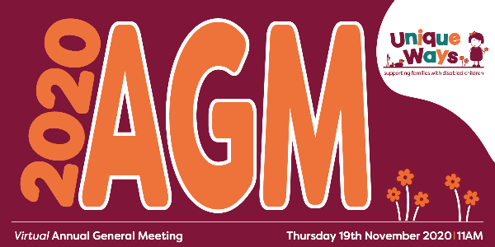

**1: 1100 - 1110**

**Welcome & format of the session**

**Chief Executive Officer: Shona Walsh**

**2: 1110**

**Formal governance**

**Chair: Oliver Wilby**

* Opening remarks & apologies.
* Minutes of last Annual General Meeting – Thursday 7th November 2019.

**3:** **1120**

**Treasurer: Nick Wigmore**

* Presentation of Annual Accounts
* Appointment of Auditors.

**4: 1130**

**Summary of achievements (year 2019 - 2020)**

* Unique Ways presentation slides.

******

***Next AGM: Thursday 18th November 2021 (provisional)***