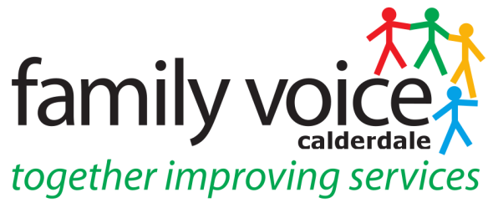
MINUTES OF STEERING GROUP MEETING
Wednesday 10th April 2019
10.30 am at Unique Ways Offices, Hanson Lane Enterprise Centre, Halifax

Present

Steering Group Members: Vikki Darby, Janine Wigmore, Jo Stockings Others: Heidi Coney (Family Voice Co-ordinator) Lisa Aldred (Contact Regional Rep)
1 Welcome and Apologies

Apologies were given from Alison Bower, Pete Ruse, Cath King, Alison Sharpe and Gabriella Walker

2. Items for AOB

- Emotional Health and Wellbeing Group & Local Transformation Plan
- Autism Assessment and Patient Choice

_________________________________________________________________________

3. Minutes of Previous Meeting and Matters Arising

Minutes of SG meeting on 13th March 2019 are a true and accurate record. Vikki queried the notes on Transport and Janine gave clarification.

4. Treasurers Report
This was in the process of being completed for the end of financial year however virtually all of the grant money had been spent.
_______________________________________________________________________

5. Grant Monitoring and Grant Application
Heidi reported that the Grant Monitoring 2018/19 needed to be completed by 30th April and was meeting with Alison S to do this the following day. As there is an Easter Break and the deadline might be difficult to meet Lisa from Contact suggested contacting the Grants Team and requesting an extension.
The Grant Application for 2019/20 has to be completed by June 10th. ACTION: suggested the Steering Group come up with ideas of how they would like the money to be spent and bring these to the next Steering Group on the 16th May. Lisa explained the Grant application form had changed slightly and that a Memorandum of Understanding would go out to Local Authorities automatically for them to sign to register support for the grant application however it would be up to the Forum to chase this.
___________________________________________________________________
6. Unique Ways Video
Heidi updated that Julie Killey had been contacted regarding distribution to SENCO’s and it would be Sarah Dickinson the SEND Support Co-ordinator would send the letter and embedded flyer out to all SENCO’s. ACTION: Heidi and Cath to meet to finalise letter to be sent out.
____________________________________________________________
7. Events

Regional Meeting on the 26th April – Heidi and Janine will attend as during the Easter Holiday.
Wheelchair Consultation – Jo reported that she couldn’t attend the event held on the 23rd April however they would keep her informed about future events regarding the Wheelchair Consultation.
Home Educators Event – Heidi reported back on this, it had not been well attended but important issues had come out of it and a survey would go out to parent members of Unique Ways.
_______________________________________________________________________

8. Work Streams/Panels

Local Offer – Jo will attend this work stream however there is no meeting taking place in April now and there is now Local Offer Live event planned this Spring/Summer.

High Needs Review – Vikki reported that the High Needs Review had been given an extra pot of money (£100K) and she had been asked to join another panel regarding how this will be spent. Reported she had attended a scoring session for tenders re High Needs Review and this had gone well.

Autism Review Strategy – SG unsure what stage this is currently at. ACTION: Heidi will ask Shona and report back.

EHWB Group – Vikki is attending these and Heidi will send her the list of the meeting dates. Janine spoke about the Local Transformation Plan and asked Vikki if this could go on the agenda at the next meeting of this group. Leah Webster is also going to attend this group and will need co-opting on to the Steering Group and sent all the dates of meetings.
________________________________________________________________________

9. Lisa Aldred Contact Regional Rep

Lisa updated the SG on her role as the new Contact Regional Rep, she has been going to the different areas within her region and attending the parent carer forum meetings to learn about what goes on. She told SG about Yorkshire Regional Forum Facebook page and Vikki and Jo asked to be added to this. Lisa seemed impressed with the work that was going on and said it was good to share information with other forums including documentation that is produced as part of the work streams i.e. What’s Next Leaflet.
______________________________________________________________________

10. AOB
- Transforming Care – Janine spoke about this and would like to invite Karen Midgley to a SG meeting to tell us about Transforming Care.
- Autism Assessment & Patient Choice – Janine spoke about a NAS group member who had noted that Patient Choice information on the Local Offer website should include Autism Assessment Services. The NAS group member had contacted NHS Improvement to seek clarification on this and that you can choose a local NHS service or another NHS service or private service. This information has been sent to the CCG and given them time to respond and then depending what their response is, this information will be shared on the Autism page of the Local Offer website.

Next meeting – Thursday 16th May 2019 at 10.30am at Unique Ways Offices

