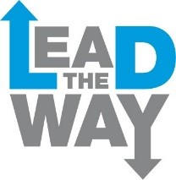
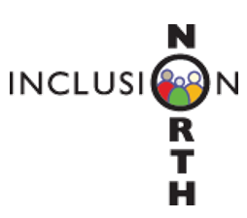

Young Leaders – Things to know
The dates for Young Leaders in 2018 are:

Tues 17 July

Tues 31 July – Wed 1 August

Tues 14 – Wed 15 August

Tues 28 – Wed 29 August

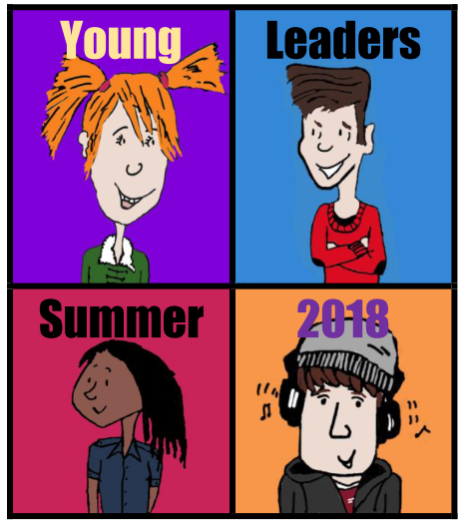 | It is for young people in Calderdale aged 16-17 who have a learning disability or autism, or both.
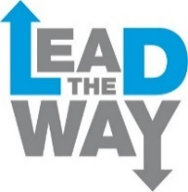  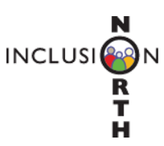 | The course is run by Inclusion North and Lead the Way.
 | The course is residential – there will be three overnight stays.
The course is free to participants.

The cost of the course will be met by Inclusion North and Calderdale Local Authority.

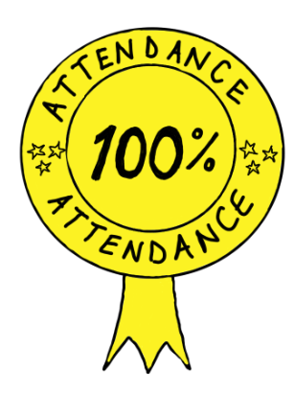 | Young Leaders must attend every session of the course.
 | The course will be fun, challenging and a chance to make new friends.
 | As well as learning new skills, there will be a chance to do activities.
 | These might include a climbing wall, archery and grass sledging.
 | On the course you will work with a partner.
 | Your partner will be someone who helps you on the course and also learns with you.
 | Your course partner will be aged 16-17 too. It could be somebody you might know.
 | We will try to match you with a partner who has the same likes and interests as you.
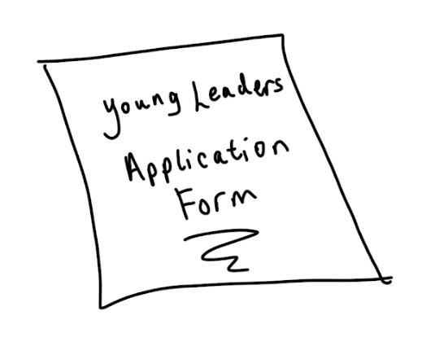 | You need to apply to go on the course.
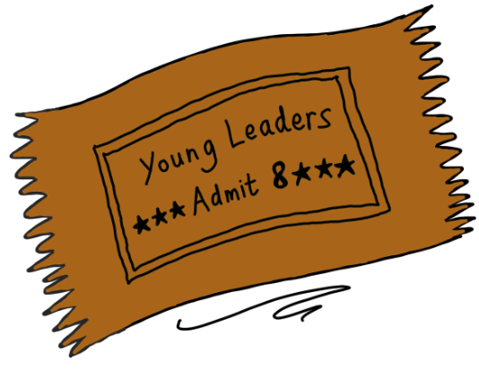 | Not everyone will get a place on the course. We only have 8 places for Young Leaders, and 8 places for course partners.
 | We will decide who goes onto the course based on your application.
 | We want to make sure that the course is right for you.
 | If you don’t get a place on the course, we will still work with you to see what other opportunities are available.
 | You need to apply by 20th April 2018.
 | We will get back to you by 4th May 2018 to let you know if you have a place on the course or not.

