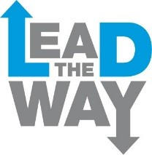

Young Leaders – Things parents need to know
The dates for Young Leaders in 2018 are:

Tues 17 July

Tues 31 July – Wed 1 August

Tues 14 – Wed 15 August

Tues 28 – Wed 29 August

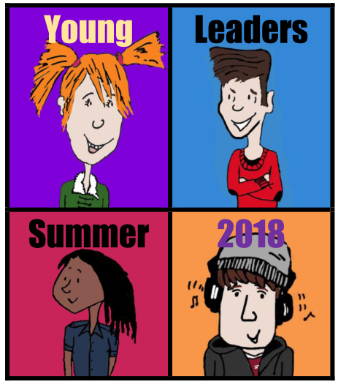 | It is for young people in Calderdale aged 16-17 who have a learning disability or autism, or both.
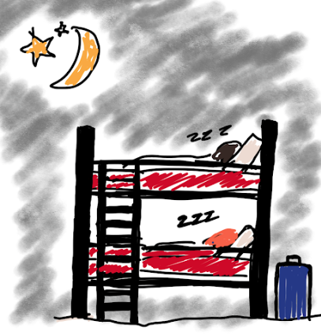 | The course is residential – there will be three overnight stays.
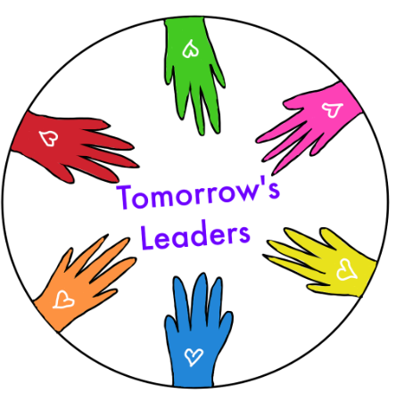 | This is a new course, based on a leadership course called Tomorrow’s Leaders run for adults with a learning disability, autism or both.
The course is free to participants.

The cost of the course will be met by Inclusion North and Calderdale Local Authority.

 | Young Leaders must attend every session of the course.
 | The course will be fun, challenging and a chance to make new friends.
 | The course is designed to help young people work together, support one another, and learn some of the skills needed to lead and guide others.
 | The young leaders on the course will be asked to do some work in between each session.
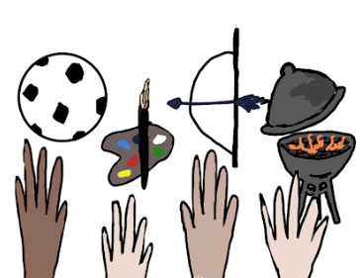 | As well as learning new skills, there will be a chance to do activities.
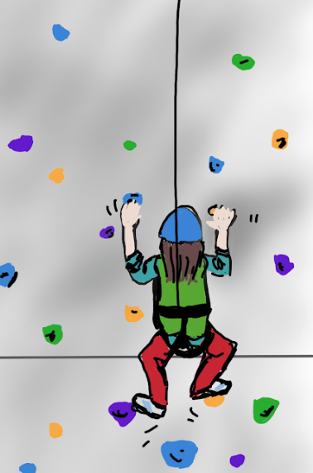 | These might include a climbing wall, archery and tobogganing.
 | On the course the young leaders will have a course partner.
 | They will be someone who helps them on the course.
 | Their course partner will be aged 16-17 too.
 | We will try to match the young leaders with a course partner who has the same likes and interests as them.
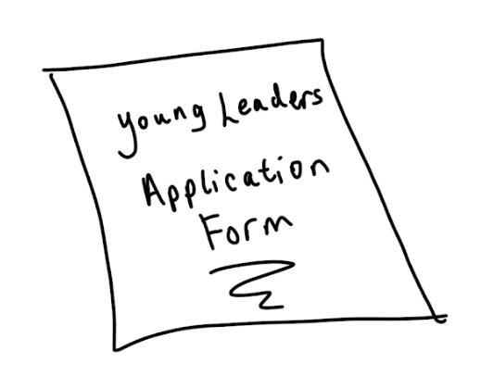 | Like the young leaders, the course partners will need to apply to be part of the course.
 | Not everyone will get a place on the course. We only have 8 places for Young Leaders, and 8 places for course partners.
 | We will decide who goes onto the course based on their application.
 | We want to make sure that the course is right for the young people who apply.
 | If your son or daughter applies and doesn’t get a place on the course, we will still work with them to see what other opportunities are available.
 | Young leaders and course partners need to apply by 20th April 2018.
 | We will get back to the applicants by 4th May 2018 to let them know if they have a place on the course or not.

