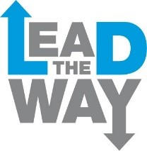

Young Leaders Application Form
Top Tips for filling out the form:

- Take your time filling out the form
- You don’t have to write down your answers, you could draw them or send us a film
- Ask someone to help you – it is always easier if you talk about your ideas with someone else
- Try to tell us as much as possible
- Make sure you get your form back to us by 20th April 2018

Name:

Address:

Telephone Number:

When you are answering the question think about:

- What do people like about me?
- What am I good at?

My answer:

When you are answering the question think about:

- What you think you would like about the course

My answer:

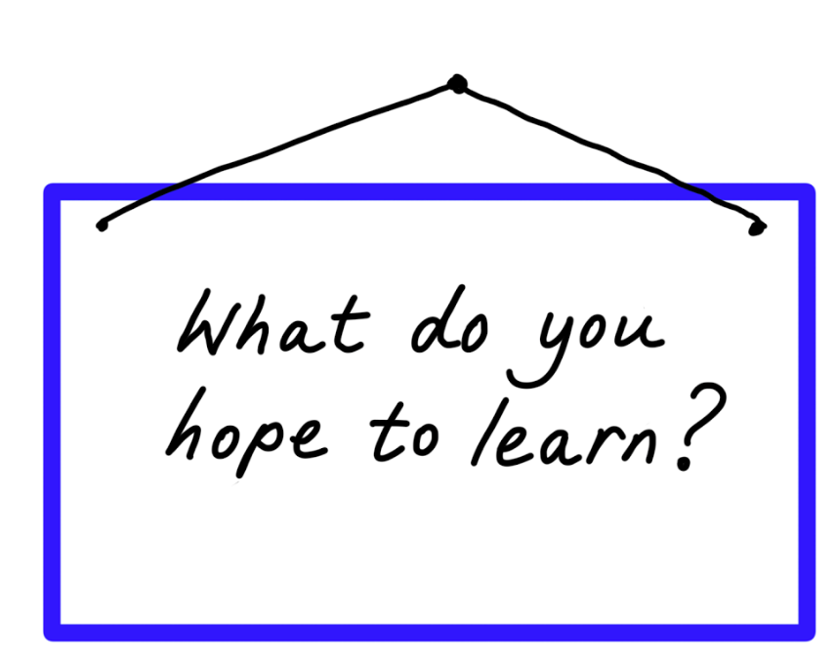
When you are answering the question think about:

- What you might learn from working with others
- What you might learn from staying away from home
- What you might learn from the course
My answer:

Please send your completed application form back to us by 20th April 2018 to:

Lucy Virgo, Inclusion North, Suite 4, Unity Business Centre, 26 Roundhay Road, Leeds LS7 1AB

Or email it to lucyvirgo@inclusionnorth.org

